SHOW RECIPE

“Chocolate Beetroot Cake”

275g (10 oz) S.R. Flour
- 65 g (2.5oz) Organic Cocoa Powder
- 220g (7.5oz) Castor Sugar
- 300ml (0.5 Pint) Sunflower Oil
- pinch of salt
- 1 Teaspoon of Vanilla Essence
- 3 free-range eggs
- 250g (9oz) Cooked Beetroot (grated)
For the icing:
- 100 g (3.5 oz) full fat cream cheese
- 125 g (4.5 oz) soft butter
- 200 g (7 oz) icing sugar
- 1 tsp vanilla essence
Sift the cocoa and flour with the salt and the sugar.
Whisk the sunflower oil, vanilla & eggs together until thick. Add the beetroot and mix well with the dry ingredients until it is a glorious purple colour.
Pour into 2 x 7” sandwich tins and bake in a pre-heated oven – no5/190c/375F for about 35minutes or when the cake springs back when lightly pressed. Allow to cool before removing from the tins.

Decorate with a cream cheese frosting, using it to fill the middle and decorate the top of the cake.

Askham, Helton & District

Village Show

Patron: Mr Charles Lowther.

Schedule and Entry Form

Askham Community Centre
Saturday 7th September 2019
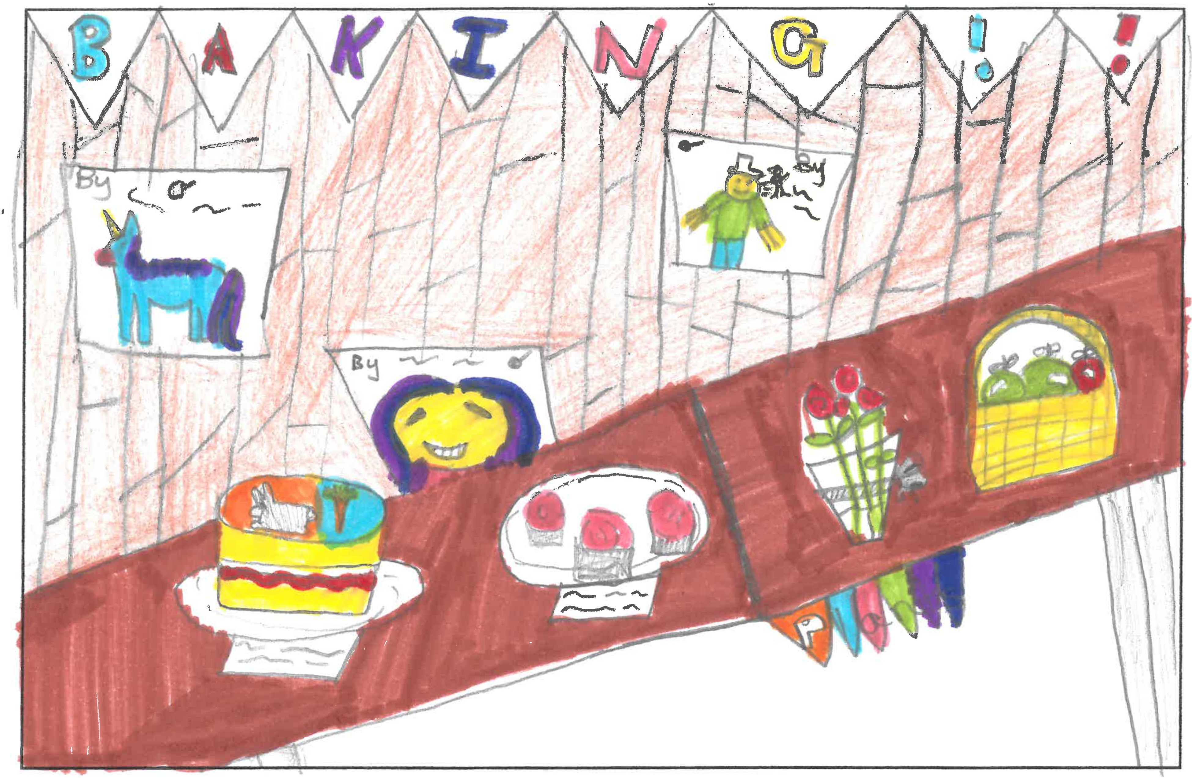
Competition winner at
Lowther Endowed Primary school
The Hall will be open for EXHIBITORS from 8am until
10.15am and judging will start at 10.30am.

The show will be open to the public from 2pm – 4pm.

Prize giving: 3.30pm followed by the auction of donated produce.
Afternoon Tea and Raffle

All proceeds to the Swimming Pool and the Village Hall

ASKHAM SHOW SCHEDULE 2019
FLOWERS  A1-Vase of mixed Sweet Peas  A2-3 Sweet Peas – single colour.  A3- A Cactus or Succulent  A4-Vase of Mixed Perennials  A5-Marigolds – 3 stems  A6- A Single Dahlia  A7-Single Rose  A8- Pot Plant- flowering  A9- An arrangement of Mixed Flowers, Fruit & Veg with a culinary theme  JAMS & PRESERVES  B1- Jar of Marmalade  B2- Jar of Chutney  B3- Jar of Lemon Curd  B4- Jar of Jam  B5- Jar of Jelly  B6- Home-made Fruit Liquor  B7- Home -made Pickle  B8 -Bottle of homemade beer | EGGS  C1- Trio of Eggs  VEGETABLES & FRUIT  D1- Tomatoes (3)  D2- Cherry Tomatoes(3)  D3- Potatoes (3)  D4- Courgettes (2)  D5- Onions (2) dressed  D6- Beetroot (3)  D7- Runner Beans (3)  D8- Leeks (2)  D9- Cucumber (1)  D10- Mixed Herbs in a jam jar  D11- Any other Vegetable (20cm plate)  D12- 3 Plums or Damsons  D13- 3 Dessert Apples  D14- 3 Cooking Apples  D15- 3 Any other Fruit  D16-A Basket, Box or Trug of mixed garden produce. | PRODUCE & BAKING  E1- Loaf of Brown Bread  E2- Speciality Bread  E3- Flapjacks (4)  E4- Cheese Scones (4)  E5- Savoury Muffins (4)  E6- SHOW RECIPE- “Beetroot  Cake” (Recipe – attached)  E7- Small Sausage Rolls (4)  E8- Battenberg Cake  E9- Viennese Whirls (4)  E10- Dish of Rum Butter -  Creamed method  E11 Fudge (6 squares).  E12- Lemon Drizzle Cake  (Loaf Tin size).  E13- Gingerbread,  (max 8”/20cm square)  E14- MEN only -Fruit Tea Bread.  E15- Victoria Sponge – Jam  Filled, made in 2 tins.  E16- 4 Decorated Cup Cakes  HANDICRAFTS  F1- Knitted or Crocheted Article  F2- A Handmade Bag  F3- “Quirky” Tea Cosy  F4- Something New from  Something Old  F5- Handmade Greetings Card  F6- A piece of handmade jewellery  F7-Any other hand made  article
SCHEDULE- continued
PHOTOGRAPHY & ART  (All Mounted please)  G1- “Caught in the Act”.  G2- “Silhouettes”  G3- A Sporting Scene  G4- A Woodland Scene.  G5- A photo of a Pet  G6- A Picture in any Medium | Y0UNG PEOPLE, under the age of 16 years are able  to enter any class free of charge.  Ages 8-11yrs  H1- A Bug Hotel  H2 -A piece of Handwriting.  H3- A mini Garden or Jungle in a seed tray or biscuit tin.  H4- Chocolate Cookies (4) | Age 7yrs & under  H4- 4 Homemade Peppermint Creams  H5 – A “Paper Plate Face”.  H6 – A Picture or a Model, of an Insect.  FAMILY ENTRY  H7 - Please make a SCARECROW with your family and bring it to the show along with a photograph of your team (in an envelope).

We are grateful to the following people for their generosity in sponsoring the show in 2018.
Askham Hall, Askham Stores, Larch Cottage Nurseries, Dalefoot Compost, T.W. Relph & Sons, Abbot Lodge, Ullswater Steamers, Sainsburys, The Punch Bowl, Lakeland, Rheged, Mike & Jenny Slee, Felicity Ashcroft, Joe & Helen Dunham.

If you would like to sponsor the show this year or give a prize for the raffle, please contact one of the committee members

Laura Harker: 01931 712168, Mary Westgarth: 01931 712233,
Linda Collison: 01931 713167, Lynne Moor :01768 606894 or Sarah Thomas: 01931 712819.

Further schedules and entry forms are available on:

www.askhamandhelton.co.uk

