SHOW RECIPE
Eyemouth Tart

Family favourite of Laura’s for many years.

2oz chopped walnuts
2oz currants
2oz desiccated coconut
2oz glace cherries chopped
2oz raisins
3oz sugar
1oz butter melted
1 egg beaten
8oz shortcrust pastry

8oz icing sugar

Roll out pastry and line a swiss roll tin. Mix together dry ingredients, add egg and butter. Spread mix over the pastry and bake in a moderate oven until golden brown. Mix the icing sugar with a little water and ice while still hot.
Please bring it in the tin.

Askham, Helton & District

Village Show

Patron: Mr Charles Lowther.

Schedule and Entry Form

Askham Community Centre
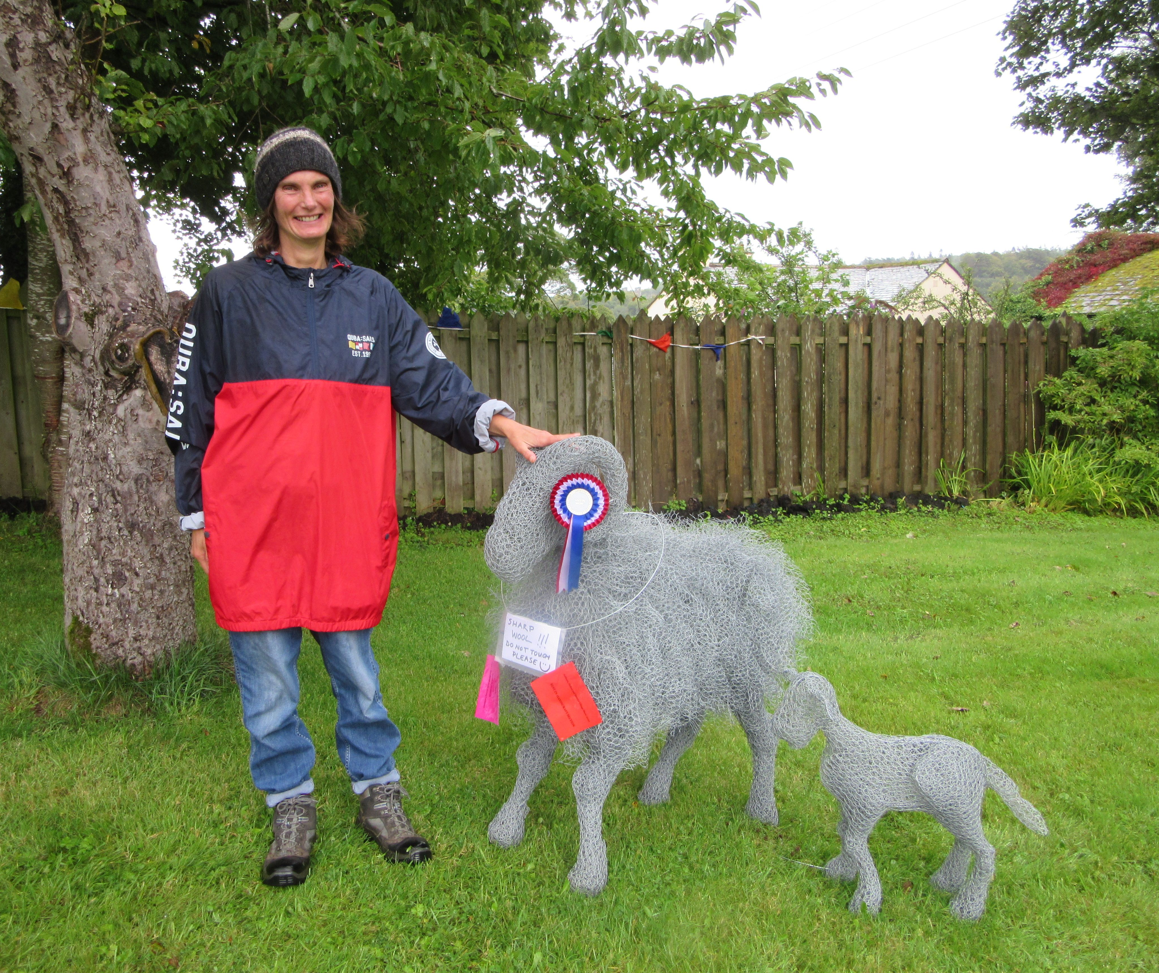
Saturday 4th September 2021

The Hall will be open for EXHIBITORS from 8am until
10.15am and judging will start at 10.30am.

The show will be open to the public from 2pm – 4pm.

Prize giving: 3.30pm followed by the auction of donated produce.
Afternoon Tea and Raffle

All proceeds to the Swimming Pool and the Village Hall

ASKHAM SHOW SCHEDULE 2021
FLOWERS  A1-Vase of mixed Sweet Peas  A2- A Cactus or Succulent  A3- Vase of Mixed Flowers  A4- Marigolds – 3 stems  A5- A Single Dahlia  A6- Single Rose  A7- Pot Plant- flowering  A8- An arrangement of Mixed Flowers, Fruit & Veg with a NHS theme  JAMS & PRESERVES  B1- Jar of Marmalade  B2- Jar of Chutney  B3- Jar of Lemon Curd  B4- Jar of Raspberry Jam  B5- Jar of Bramble Jelly  B6- Jar of any other fruit jam  B7 Home-made Fruit Liquor | EGGS  C1- Trio of Eggs  VEGETABLES & FRUIT  D1- Tomatoes (3)  D2- Cherry Tomatoes on the vine  D3- Potatoes (3)  D4- Courgettes (2)  D5- Onions (2)cut and tied  D6- Beetroot (3)  D7- Runner Beans (3)  D8- Carrots (2)  D9- Mixed Herbs in a jam jar  D10- Any other Vegetable (20cm plate)  D11- 3 Plums or Damsons  D12- Soft fruit on a saucer  D13- 3 Dessert Apples  D14- 3 Cooking Apples  D15- 3 Any other Fruit  D16-Weird and wonderful fruit or vegetable | PRODUCE & BAKING  E1- Loaf of White Bread  E2- Plaited loaf  E3- Carrot cake  E4- Fruit Scones (4)  E5- Chocolate Chip cookies (4)  E6- SHOW RECIPE-  Eyemouth Tart  (Recipe – attached)  E7- Small Vegetarian Sausage  Rolls (4)  E8- 2 individual savoury tartlets  up to 4in  E9- Dish of Rum Butter -  Melted method  E10- Gingerbread,  (max 8”/20cm square)  E11 MEN only –Round of  Shortbread  E12- Victoria Sponge – Jam  Filled, made in 2 tins.  E13- 4 Decorated Cup Cakes  HANDICRAFTS  F1- Bunting 2m long  F2- Article that includes pompoms  F3- Any craft with a local theme  - textiles  F4- Original poem entitled  “Celebration”  F5- Handmade Thank you Greeting  Card  F6 – Picture in any medium
SCHEDULE- continued
PHOTOGRAPHY & ART  (All Mounted please)  G1- Fells  G2- Portrait  G3- Moonlight  G4- 4 legged friend  G5- Happiness is….?  Y0UNG PEOPLE, under the age of 16 years are able  to enter any class free of charge. But this will not be included in the child prizes | Ages 12-16  H1 – Tree in mixed media  H2- An original poem on climate change  H3 Rainbow cake  Ages 8-11yrs  H4- A mini Garden or Jungle in a seed tray or biscuit tin  H5 –Handwriting of a page of Beatrix Potter  H6- Decorated cupcakes on a garden theme | Age 7yrs & under  H7 - Decorated gingerbread biscuit  H8 - A mini Garden or Jungle in a seed tray or biscuit tin  H9 - Flower in any medium 2D or 3D

We are grateful to the following people for their generosity in sponsoring the show in 2019.
Askham Hall, Askham Stores, Larch Cottage Nurseries, Dalefoot Compost, T.W. Relph & Sons, Abbot Lodge, Ullswater Steamers, Sainsburys, The Punch Bowl, Lakeland Embroidery, Rheged, Mike & Jenny Slee, Felicity Ashcroft, Joe & Helen Dunham.

If you would like to sponsor the show this year or give a prize for the raffle, please contact one of the committee members

Laura Harker: 01931 712168, Mary Westgarth: 01931 712233,
Linda Collison: 01931 713167, Sarah Banks 01931 712801 or Sarah Thomas: 01931 712819.

Further schedules and entry forms are available on:

www.askhamandhelton.co.uk

