SHOW RECIPE : CUMBERLAND RUM NICKIE

**Ingredients**

* 8oz (225g) rich shortcrust pastry
* 3 medium cooking apples
* 1 tbsp Demerara sugar
* 4oz (125g) chopped dates
* 1 tbsp water
* 1 tbsp dark rum
* 2oz (50g) softened butter

**Instructions**

Line an 8” (20cm) pie plate with half the pastry.

Put in the sliced apples and sprinkle with the sugar.

Mix the dates, water, rum and butter and spread over the apples.

Top with the remaining pastry, and brush with milk.

Bake at Gas Mark 6 (200C, 400F) for 15 minutes, then at Gas Mark 4 (180C, 350F) for a further 15 minutes until golden brown.

Askham, Helton & District

Village Show

Patron: Mr Charles Lowther.

Askham Community Centre

Saturday 30th August 2025

**SCHEDULE & ENTRY FORM**

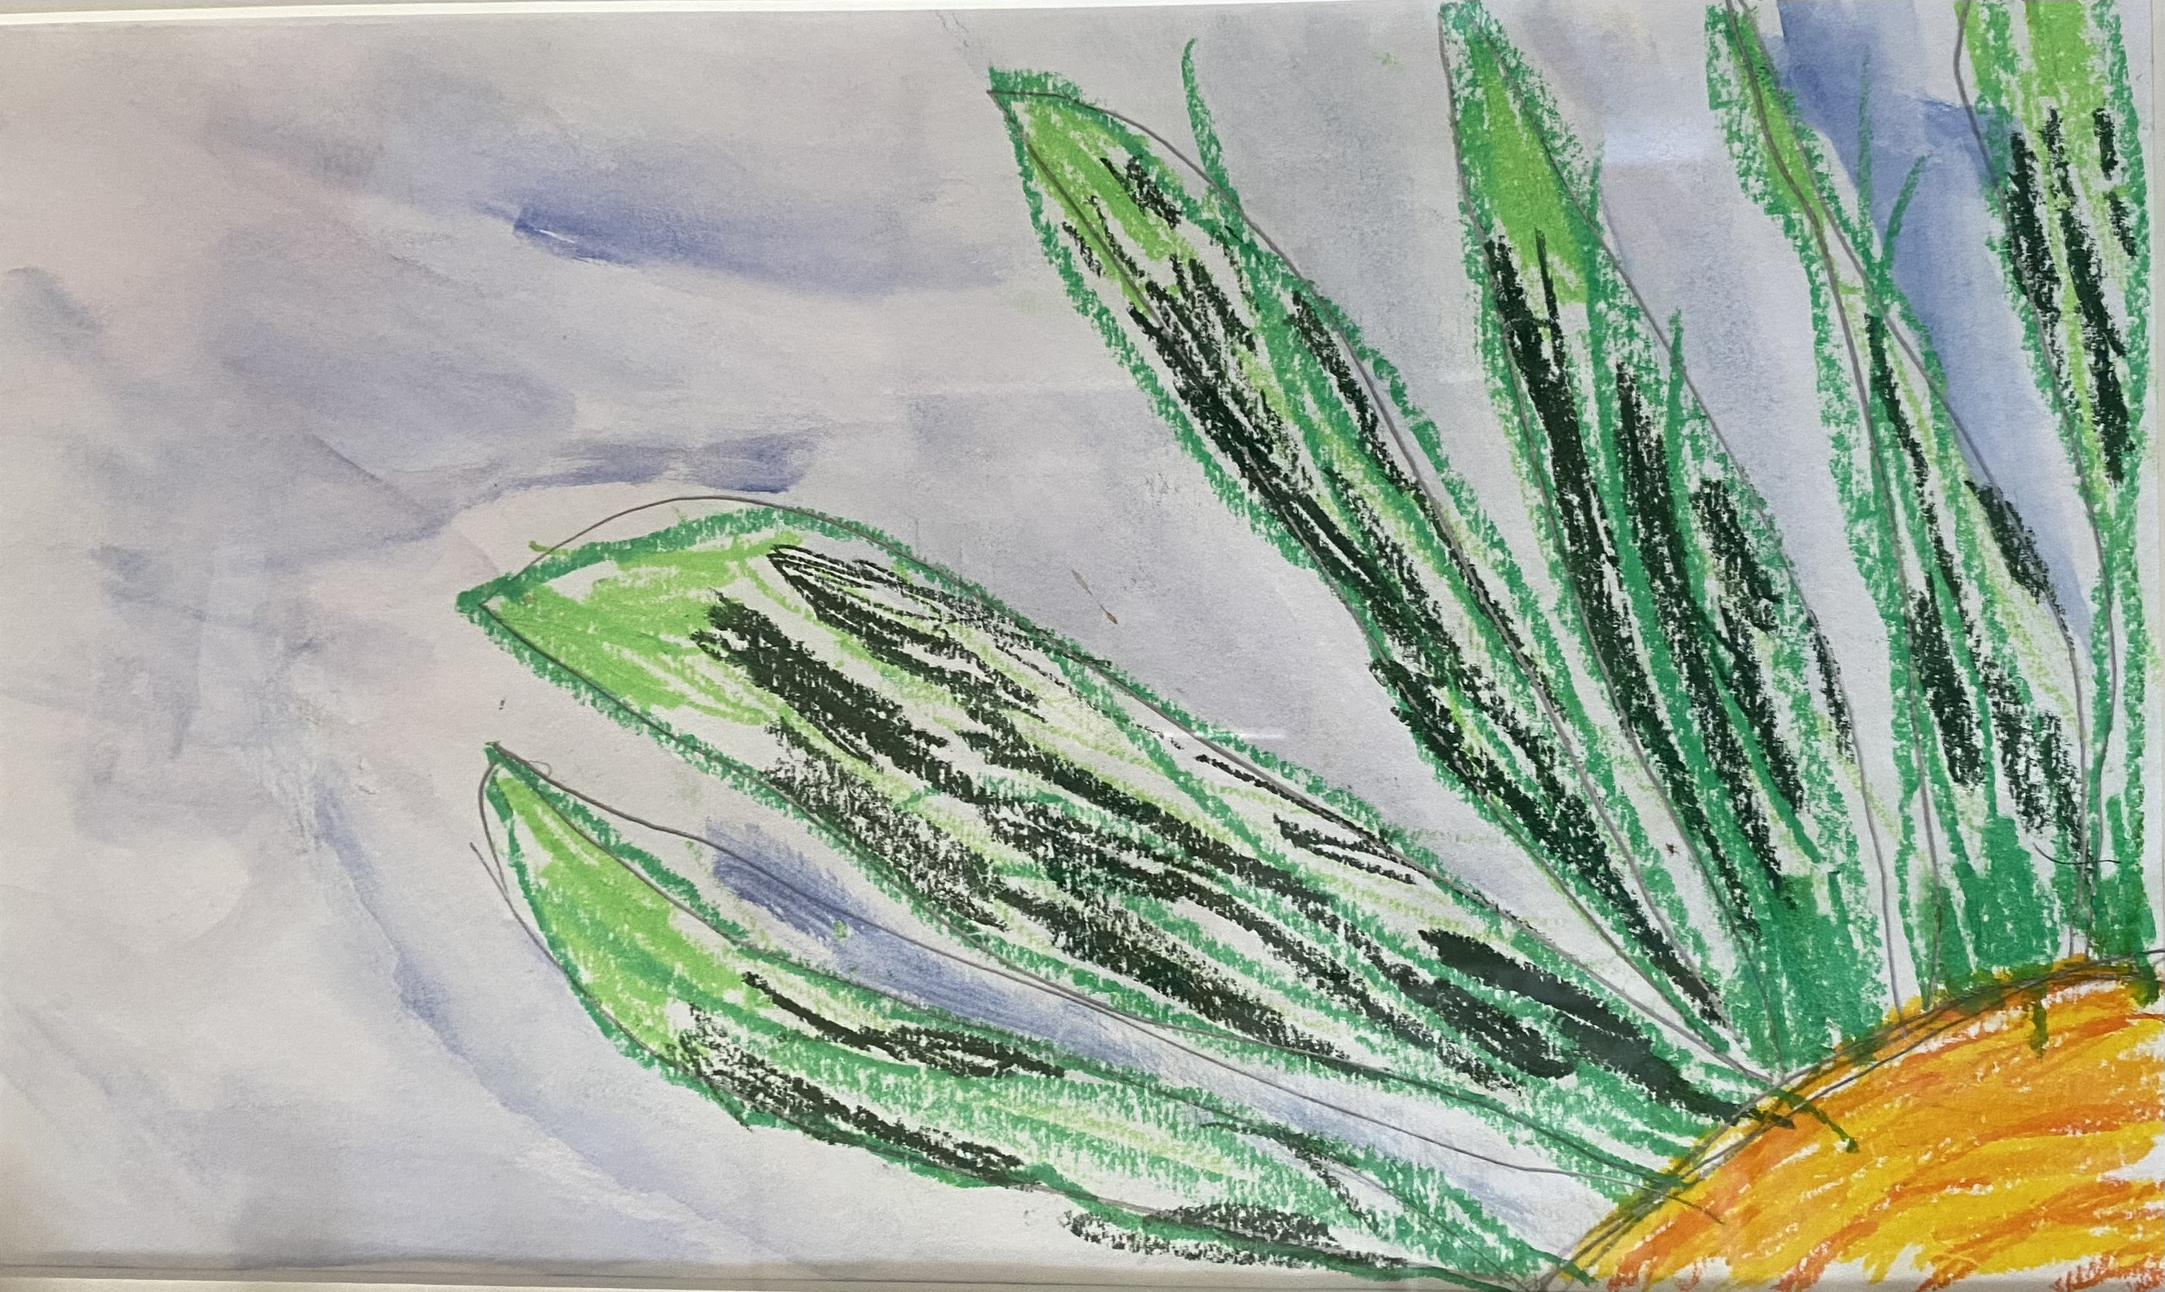

“Sunflower” by Macsen Lowther – 2024 Show prizewinnner



Online entries may be made using this link <https://tally.so/r/mVaz86>.

The Hall will be open for EXHIBITORS from 8.30am until 10.15am, and Judging will start at 10.30am.

All proceeds to the Village Hall/Swimming Pool

The show will be open to the public from 2pm – 4pm

Prize giving: 3.30pm followed by Auction and Raffle

**ASKHAM SHOW SCHEDULE 2025**

|  |  |  |
| --- | --- | --- |
| **FLOWERS**  **A1**- Vase of mixed Sweet Peas  **A2**- A Cactus or Succulent  **A3**- Vase of Mixed Flowers  **A4**- Marigolds – 3 stems  **A5**- A Single Dahlia  **A6-** Single Rose  **A7-** A perfect but lovely flower in a vase  **A8**- An orchid plant  **A9**- Michaelmas Daisies – 3 stems  **A10**- An Arrangement in a cup and saucer  **JAMS & PRESERVES**  **B1-** Jar of Marmalade  **B2**- Jar of Chutney  **B3**- Jar of Lemon Curd  **B4-** Jar of Raspberry Jam  **B5**- Jar of Apple Jelly  **B6-** Jar of any other fruit jam  **PHOTOGRAPHY (all mounted, please)**  **B7**- Jar of any other fruit jelly  **B8**- Home-made alcoholic drink  **CRAFTS & ART**  **F1-** A knitted article  **F2**- A crocheted article  **F3**- A painted stone  **F4-** A handmade Bookmark  **F5-** An upcycled item  **F6**- A poem entitled “What brings me Joy”  **F7-** Any other craft Item  **F8-** A picture in any medium  **SPONSORSHIP**  We are grateful to the following organisations and people for their generosity in sponsoring last year’s Show:  **Askham Hall, Askham Stores, Health Barn, Dalefoot Composts,**  **Lowther Castle, Threadneedle Corner, Verey Bookshop,**  **Felicity Ashcroft, Val and Tony Corbett, Joe Cann and Helen Dunham,**  **Sarah and John Banks**  **If you would like to Sponsor the Show this year or donate a prize for the Raffle, please contact one of the committee members**:  Laura Harker 01931 712168 Sarah Thomas 01931 712819  Mary Westgarth 01931 712233 Sarah Banks 01931 712801  Pauline Price 07746 866655 | **EGGS**  **C1**- Trio of Eggs  **VEGETABLES & FRUIT**  **D1-** Tomatoes (3)  **D2**- Cherry Tomatoes on the vine  **D3 -** Potatoes (3)  **D4 -** Courgettes (2)  **D5**- Carrots (3)  **D6** -Onions (2) cut & tied  **D7**- Beetroot (3)  **D8**- Runner Beans (3)  **D9-** Cucumber (1)  **D10**- Any other Veg (3)  **D11**-Mixed Herbs in a jar  **D12** - Longest Runner Bean  **D13**- 3 Plums or Damsons  **D14**- Transform a fruit or vegetable into something else  **D15**- 3 Dessert Apples  **D16**- 3 Cooking Apples  **D17**- Any other Fruit (3)    **G1** – A portrait  **G2** – Hills and Mountains  **G3** – A “mistake” photo  **G4** – Being Active  **YOUNG PEOPLE**  **Age 7yrs & under**  **H1**- A dotty picture on kitchen towel  **H2**- A sheep in any medium  **H3**- A Superhero picture  **Ages 8-11yrs**  **H4**- A posy  **H5**- Paint or draw your favourite book cover  **H6**- An individual size Pizza face | **PRODUCE & BAKING**  **E1** – A Wholemeal Loaf baked in a 2lb loaf tin  **E2**- 6 Bread Rolls in a basket  **E3**- Date & Walnut Loaf in a 1lb tin  **E4**- Sultana Scones (4)  **E5**- Savoury Scones (4)  **E6**- SHOW RECIPE : Cumberland Rum Nickie **(**See back page)  **E7**- Dessert in a glass  **E8** – Gingerbread 8” square  **E9**- Choc Chip Cookies (4)  **E10**- Victoria Sponge, Raspberry Jam filled only, made in 2 x 8” tins  **E11**- Butterfly Cakes (4)  **E12**- Sausage Rolls (4)  **E13-** A decorated vegetable cake  **E14 –** Coconut Ice (4 )  **E15** – MEN ONLY Rocky Road (4 pieces)    **G5** – Skyscape  **G6** –A photo for the cover of the 2026 Schedule  **G7** – Friendship  **G8** – Helping (+ caption)  **Ages 12-16yrs**  **H7**- A copy of a favourite artist’s picture  **H8**- A Mars Bar cake  **H9**- A photograph |
|  |  |  |